Chapter: Understanding Deployments and Replica Sets in Kubernetes

Introduction: The Foundation of Kubernetes Application Management
- [00:00 → 01:40]
This chapter explores the core Kubernetes concepts of deployments, replica sets, and replication controllers, which are crucial for managing applications in a containerized environment. Kubernetes orchestrates containers running inside pods, and these pods must be reliably maintained for high availability and scalability. A replication controller or replica set ensures that a specified number of pod replicas are always running, providing self-healing capabilities by automatically replacing failed pods. The more modern replica set supersedes the replication controller, offering improved flexibility. Meanwhile, deployments build on replica sets, adding advanced features like rolling updates and rollbacks to facilitate seamless application upgrades without downtime.
- Key vocabulary:
  - Pod: The smallest deployable unit in Kubernetes, encapsulating one or more containers.
  - Replication Controller: A legacy Kubernetes object ensuring a specified number of pod replicas are running.
  - Replica Set: An improved version of replication controller that manages pods and supports label selectors.
  - Deployment: A higher-level abstraction that manages replica sets and facilitates rolling updates and rollbacks.
  - Self-healing: Kubernetes’ ability to replace failed pods automatically.
  - Rolling update: Incremental upgrade mechanism that updates pods one at a time without downtime.

Section 1: Limitations of Standalone Pods and the Need for Replication
- [02:12 → 04:39]
Running a single pod alone exposes the application to downtime if the pod crashes. For example, if a user accesses an NGINX pod and it crashes, the user experiences no response. This limitation exemplifies why orchestration is essential. Kubernetes solves this by using a replication controller to maintain the desired number of pod replicas. This controller monitors pods and automatically spins up new pods (self healing) if any fail, ensuring high availability. Multiple replicas also enable load distribution, preventing traffic from bottlenecking on a single pod.

Section 2: Replication Controller and Its Role
- [04:39 → 07:46]
The replication controller is a Kubernetes resource managed by the controller manager. It ensures that the specified number of pod replicas are always running. If a pod crashes or is deleted, the replication controller immediately creates a replacement pod with the same configuration. This controller also handles load balancing by directing traffic only to healthy pods, using internal algorithms to identify pod health. For instance, if three replicas are requested, the replication controller maintains exactly three pods, scaling up if any fail.

Section 3: Scaling Pods and Nodes Manually
- [07:46 → 10:06]
Scaling the number of pod replicas is crucial to handle increased traffic. Users can manually increase replicas from, for example, two to three to meet demand. If the current node runs out of resources (CPU, memory), Kubernetes allows scaling out by adding new nodes to the cluster. The replication controller can distribute pods across multiple nodes, expanding capacity horizontally. This manual scaling is foundational before introducing auto-scaling mechanisms covered in later lessons.

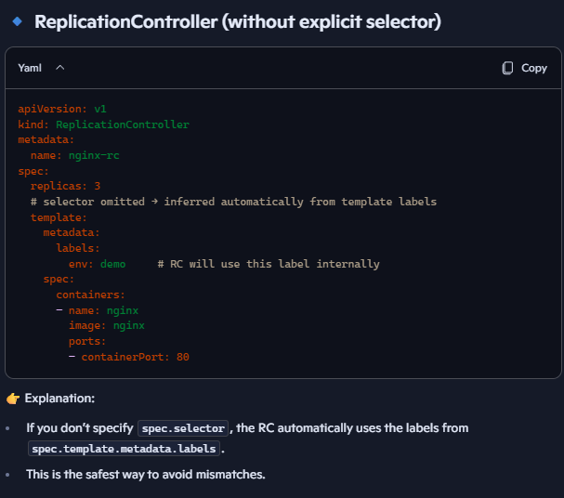
Section 4: Demonstration of Replication Controller Configuration
- [10:06 → 16:24]
The practical setup involves creating a YAML manifest defining a replication controller. This manifest includes:
- apiVersion: v1
- kind: ReplicationController
- Metadata such as name and labels
- A spec section with a template that defines the pod specification (metadata and container details).
- In ReplicationController, if you omit spec.selector, Kubernetes automatically infers the selector from the labels defined in the Pod template (spec.template.metadata.labels). RC will internally use selector: { env: demo }. For RC we can have spec.selector for simple equality only (key=value). RC can “adopt” Pods only if they exactly match its selector. RC cannot use advanced selectors (matchExpressions). RC adoption is fragile — if you change the Pod template labels, RC won’t adopt new Pods. RC cannot manage multiple label conditions, only single label equality match.
- A replicas field specifying the desired number of pod instances.
Applying this manifest with kubectl apply spins up the desired pods, all managed by the replication controller. Commands like kubectl get pods and kubectl describe pod help verify the state and health of pods and controllers.

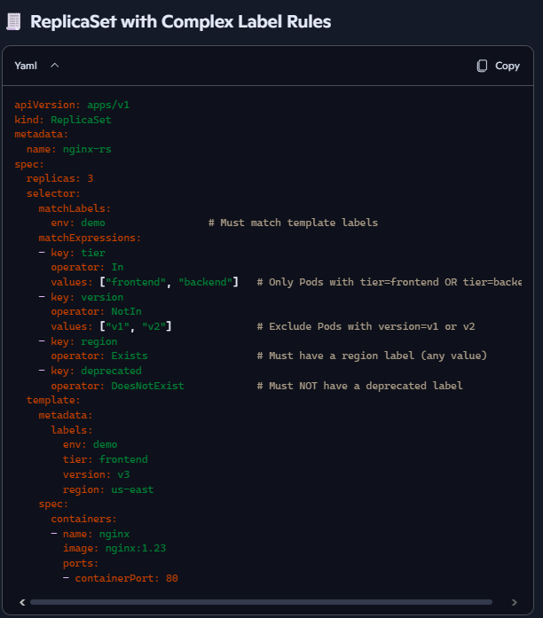
Section 5: Transition from Replication Controller to Replica Set
- [16:24 → 19:47]
The replica set is the modern replacement for the replication controller and is preferred in current Kubernetes versions. The key differences include:
- Selector: required, supports matchLabels and matchExpressions. RS can adopt Pods with complex label rules. More flexible adoption than RC.
- The API group changes to apps/v1 from the legacy v1.
- Replica sets provide more flexibility and better integration with higher-level objects like deployments.
We can scale replicas both by modifying YAML and using live edits or imperative commands kubectl scale.
You cannot create a Kubernetes ReplicaSet using a single, direct kubectl create replicaset imperative command. Instead, the recommended approach is to create a Deployment, which automatically manages a ReplicaSet for you.

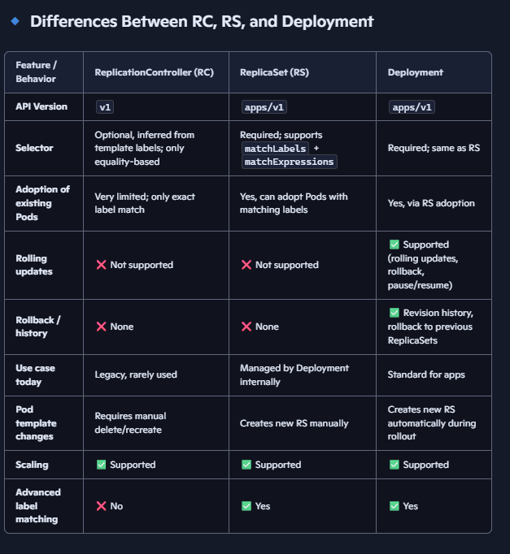
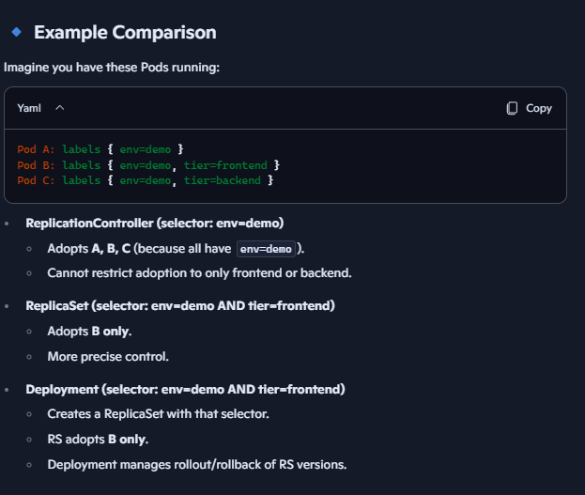

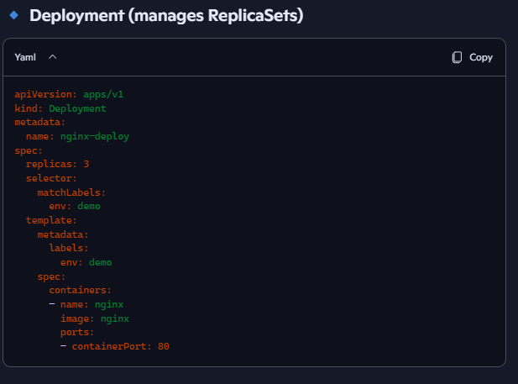
Section 6: Deployments for Managing Replica Sets and Rolling Updates
- [23:20 → 26:47]
Deployments are a higher-level abstraction managing replica sets and pods. Deployment doesn’t adopt Pods directly. It manages ReplicaSets, which then adopt Pods. Deployment is designed to facilitate rolling updates and rollbacks with zero downtime. While replica sets can update pods, they do so all at once, potentially causing downtime. Rolling updates in Deployments created new replica set and update pods incrementally: they spin up new pods with updated versions before terminating old ones, keeping the application available throughout. This feature is critical for production environments, such as banking or financial services, where uptime is paramount. Allow rollback to previous versions if if update fails or is undesirable. Uses revision history stored in Deployment. Essential for mission-critical applications requiring uninterrupted service.

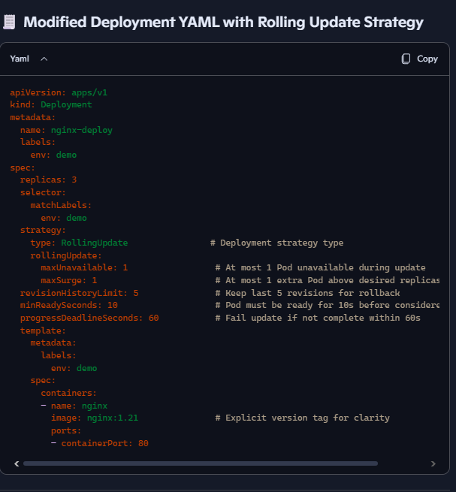
Explanation of Rolling Update & Rollback Parameters
- strategy.type: RollingUpdate
  - Default strategy. Updates Pods gradually instead of deleting all at once.
- rollingUpdate.maxUnavailable
  - Number/percentage of Pods that can be unavailable during update.
  - Example: 1 → ensures at least 2 Pods remain running during update (out of 3).
- rollingUpdate.maxSurge
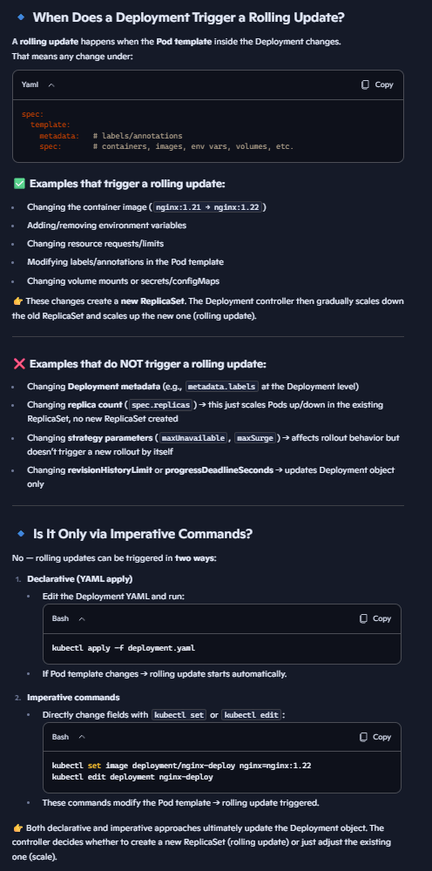
  - Number/percentage of extra Pods allowed above desired replicas during update.
  - Example: 1 → can temporarily run 4 Pods while updating 3 replicas.
- revisionHistoryLimit
  - Number of old ReplicaSets kept for rollback.
  - Example: 5 → you can roll back up to 5 previous versions.
- minReadySeconds
  - Pod must be ready for this duration before considered available.
  - Helps avoid flapping Pods being marked available too soon.
- progressDeadlineSeconds
  - Timeout for deployment progress. If exceeded, deployment is marked failed.

Imperative Commands

1. Create Deployment
kubectl create deployment nginx-deploy --image=nginx:1.21 --replicas=3

2. Update Image (Triggers Rolling Update)
kubectl set image deployment/nginx-deploy nginx=nginx:1.22

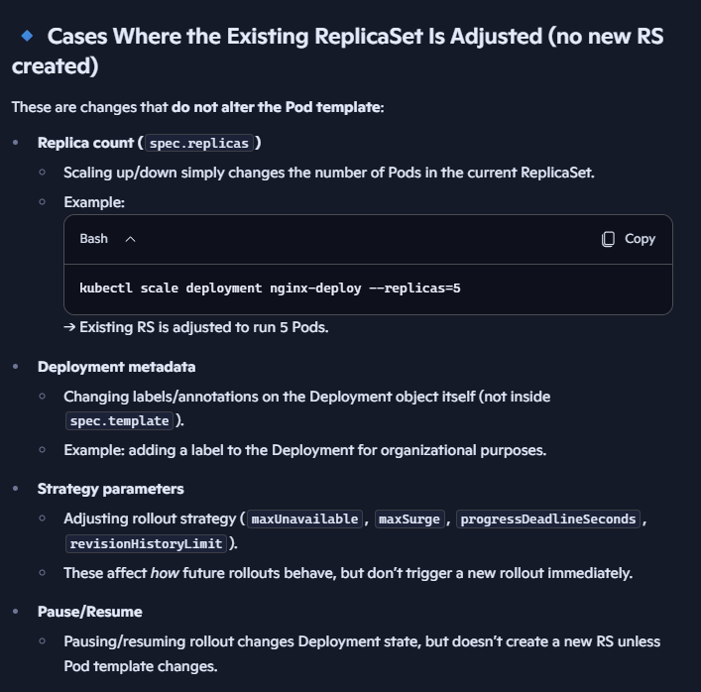
3. Check Rollout Status
kubectl rollout status deployment/nginx-deploy

4. View Rollout History
kubectl rollout history deployment/nginx-deploy
kubectl describe deployment/nginx-deploy

5. Rollback to Previous Revision
kubectl rollout undo deployment/nginx-deploy

6. Rollback to Specific Revision
kubectl rollout undo deployment/nginx-deploy --to-revision=3

7. Pause & Resume Rollout
kubectl rollout pause deployment/nginx-deploy
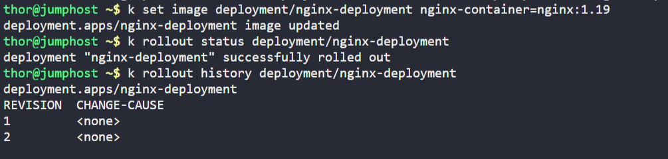
kubectl rollout resume deployment/nginx-deploy

